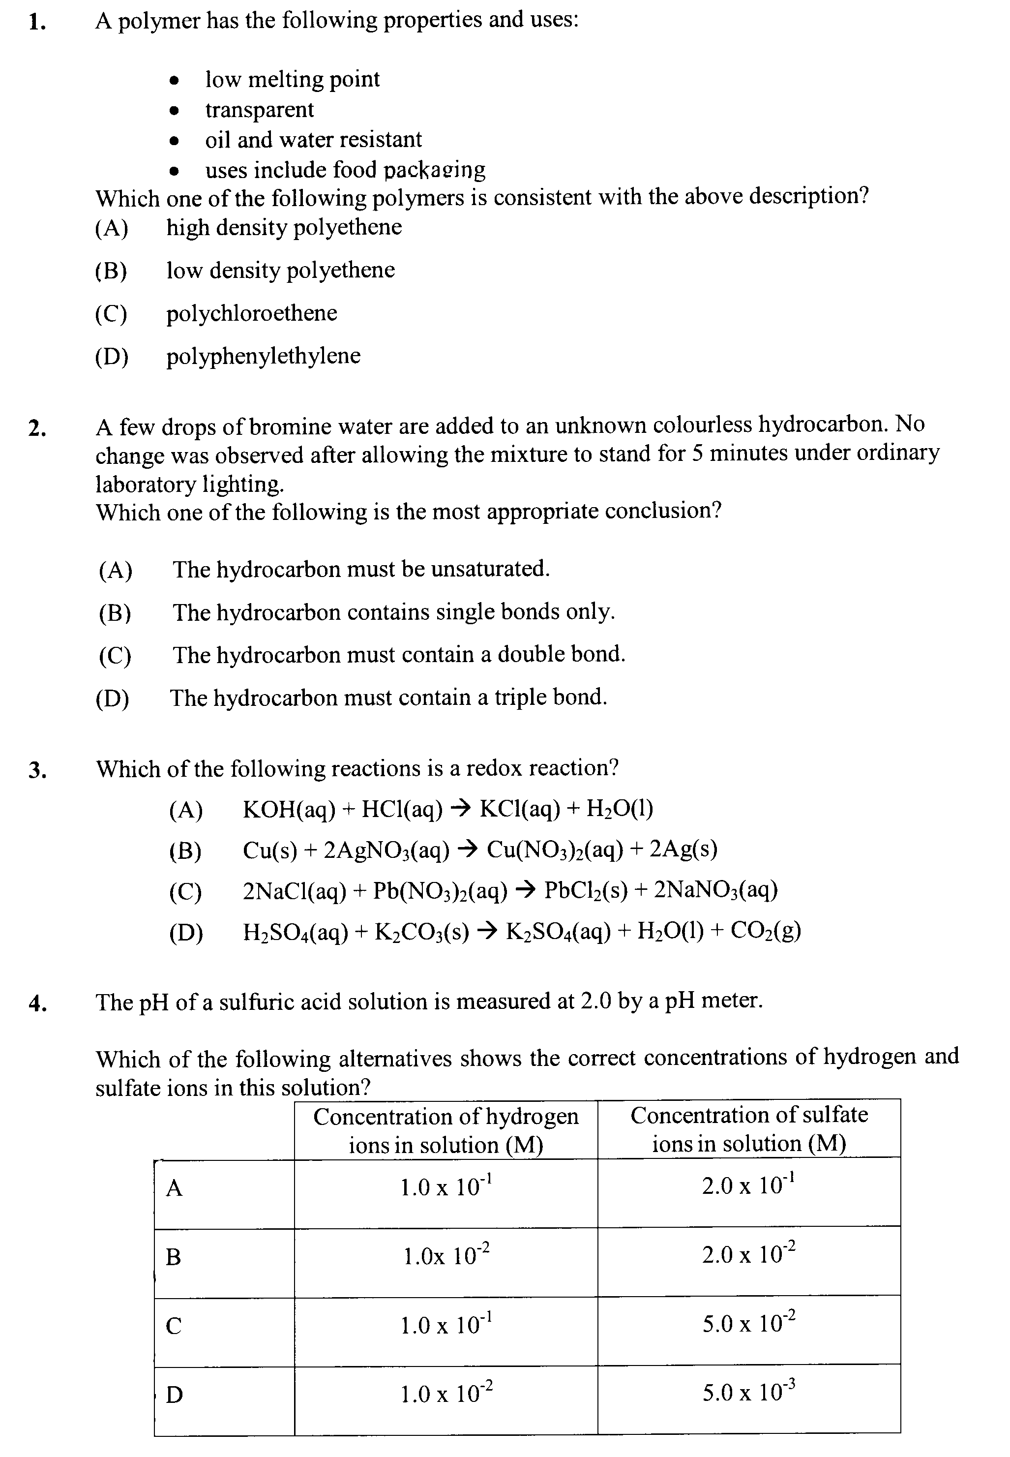
FORT STREET – Y12 HALF YEARLY EXAM – 2009

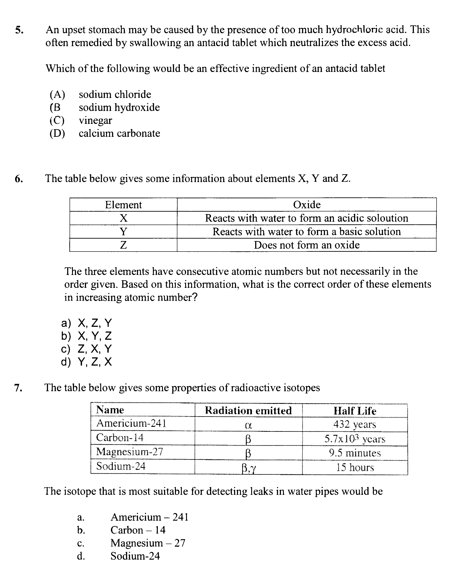

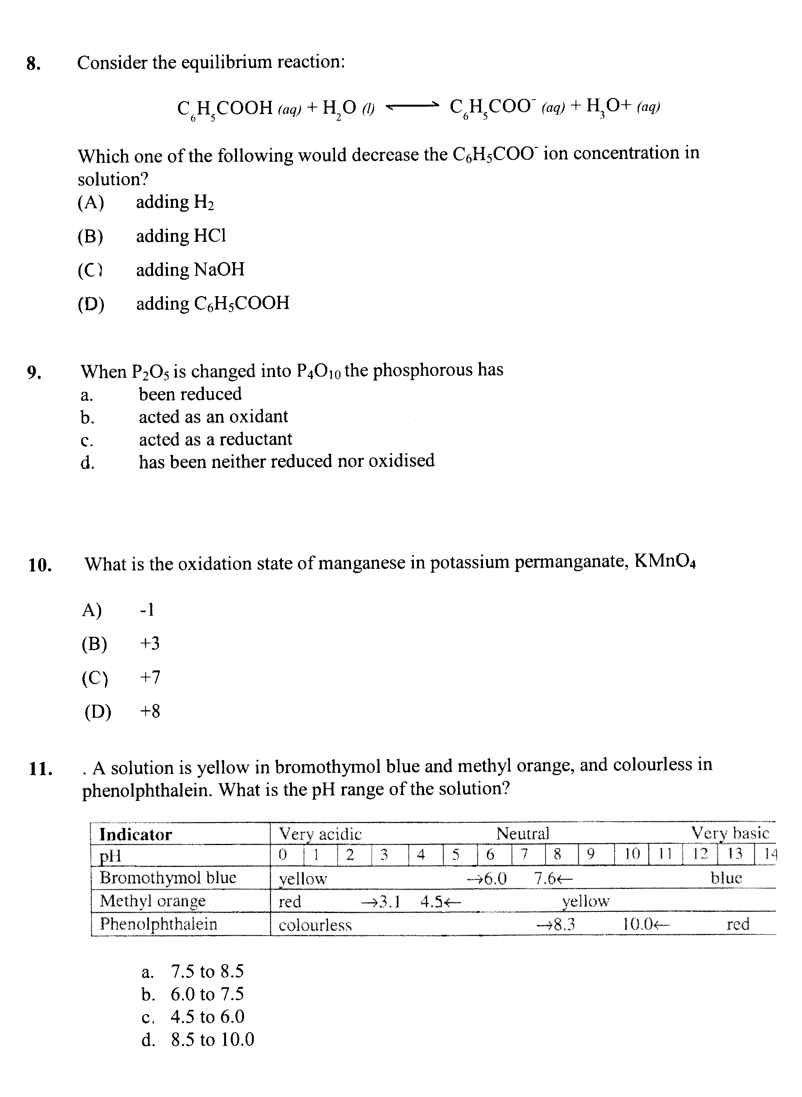

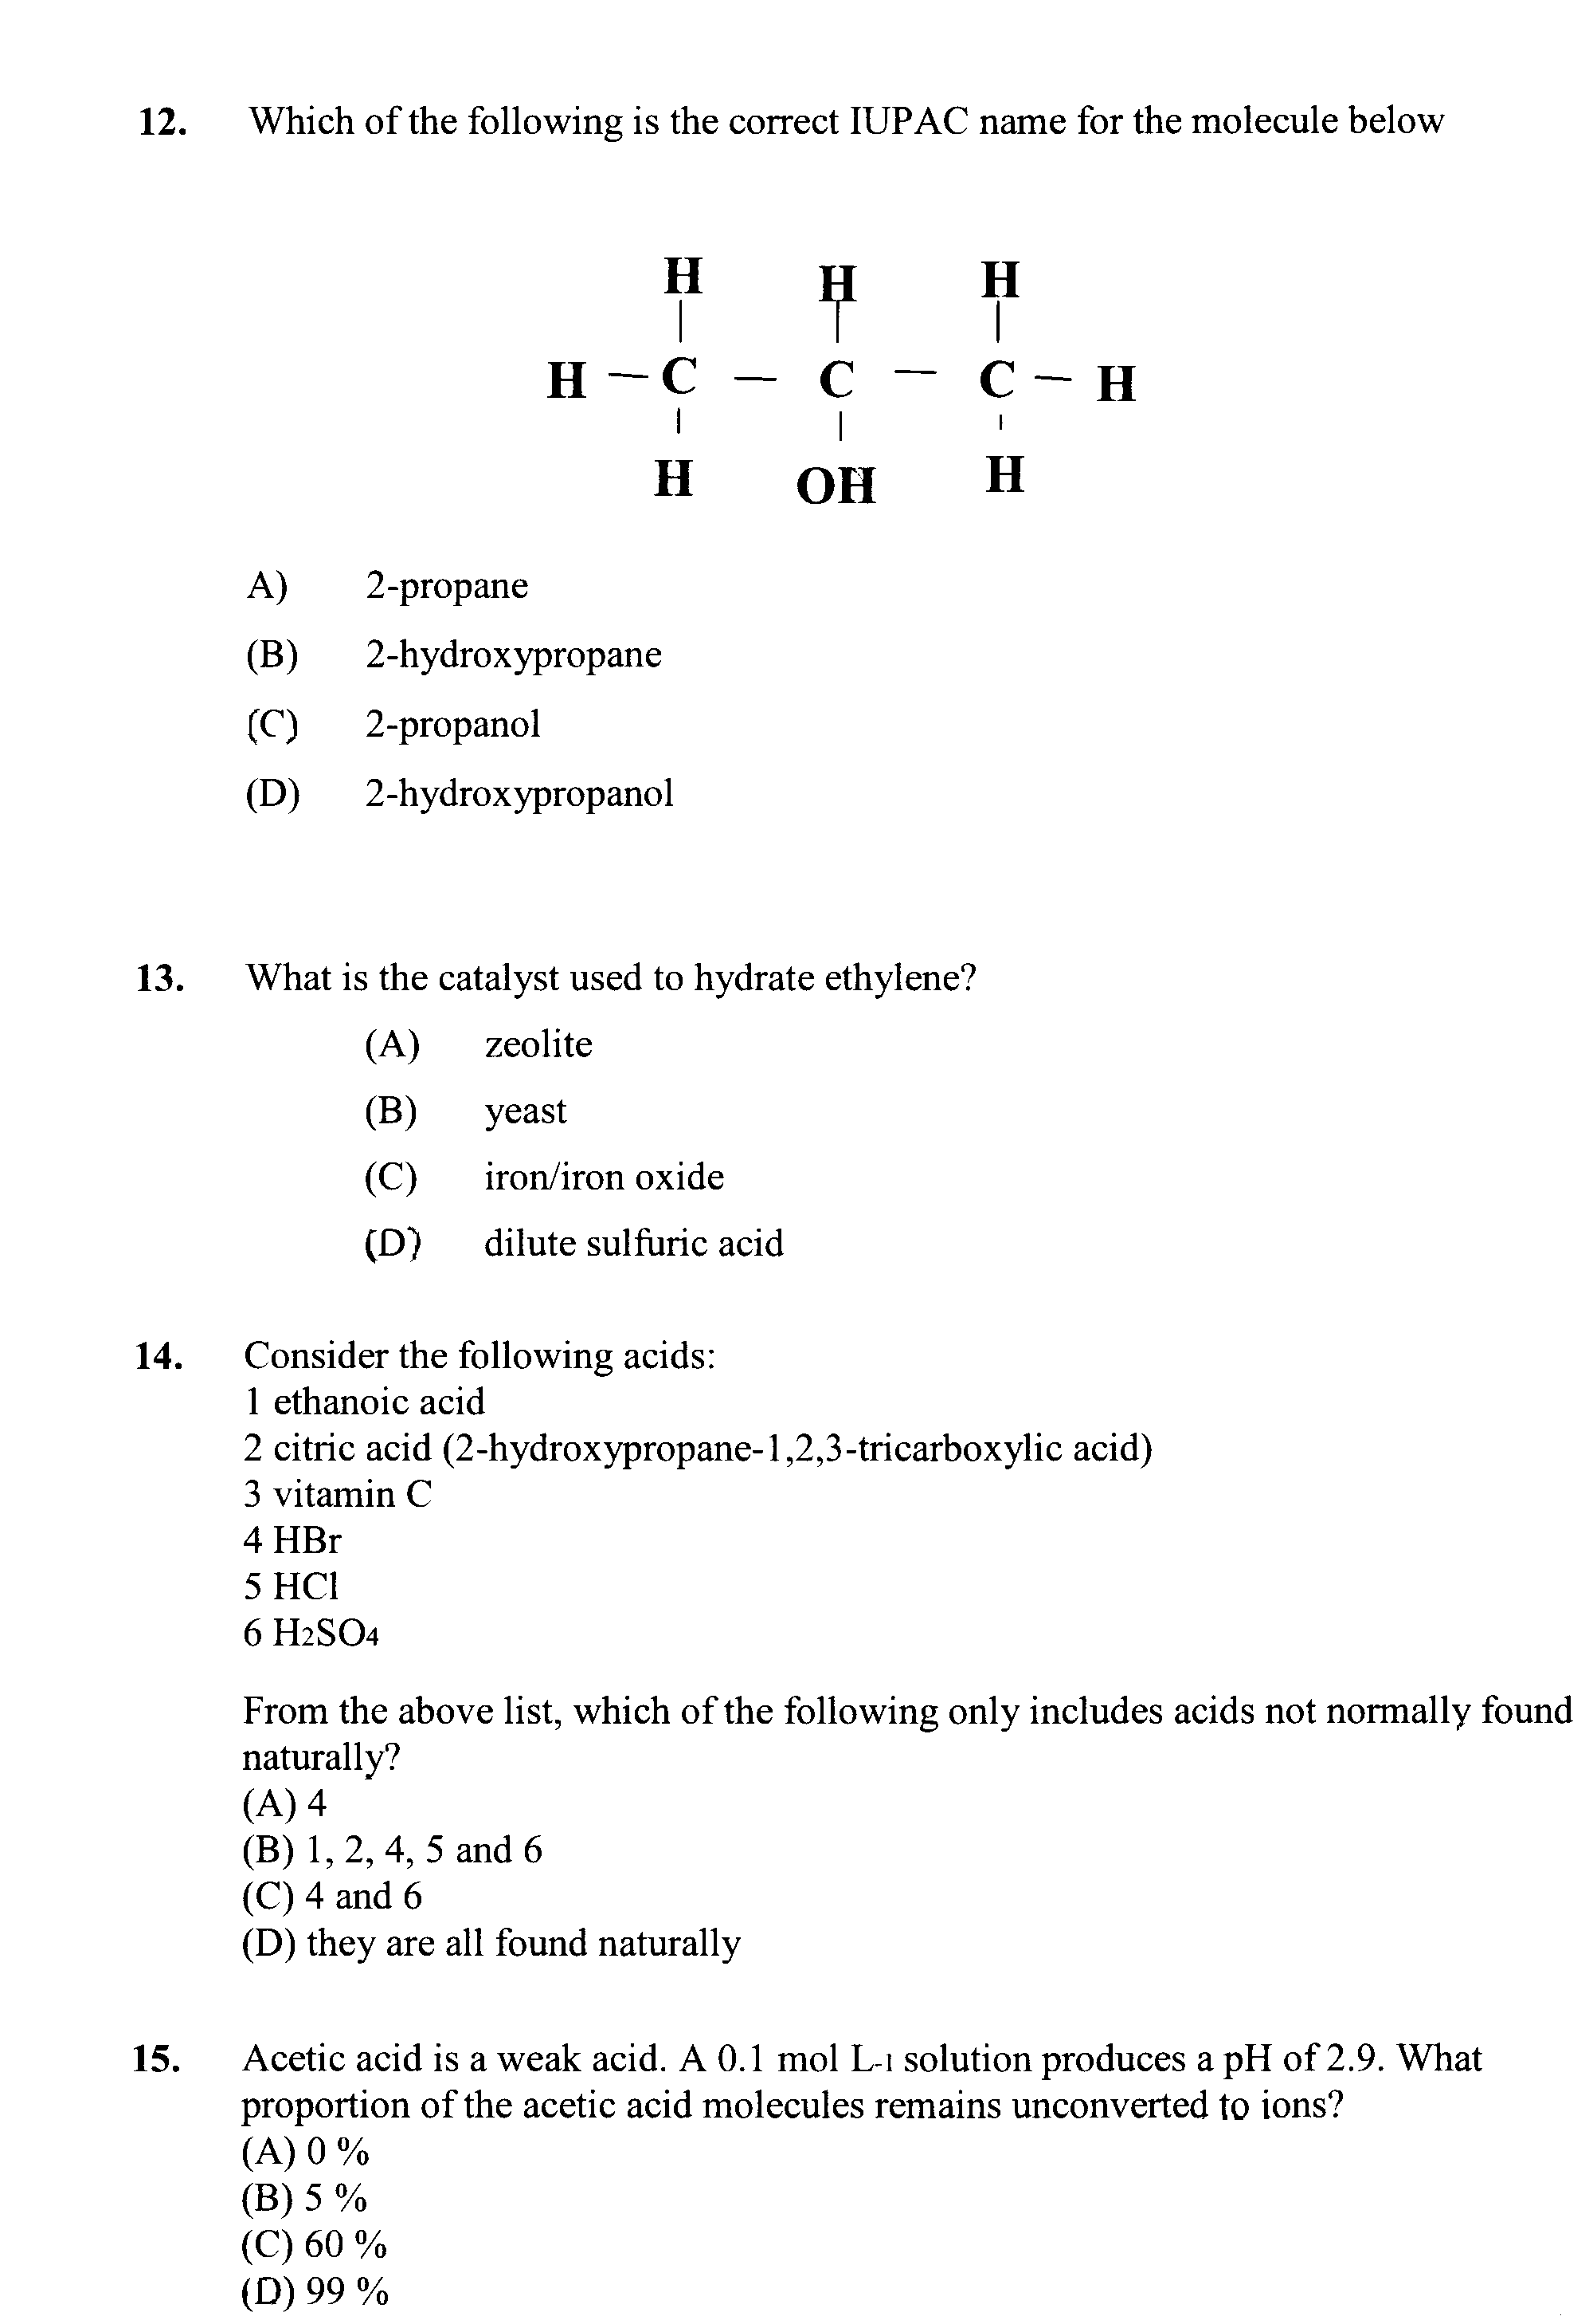

Part B
Attempt questions 16-25
Allow about 1 hour and 30 minutes for this part

Question 16 (3 marks)

Polyvinylchloride is an industrially important polymer

Explain ONE use of this polymer with reference to its properties

…………………………………………………………………………………………………………

…………………………………………………………………………………………………………

…………………………………………………………………………………………………………

…………………………………………………………………………………………………………

…………………………………………………………………………………………………………

…………………………………………………………………………………………………………

…………………………………………………………………………………………………………

…………………………………………………………………………………………………………

Question 17 ( 3 marks)

Coal fired power stations can contribute to the problem of acid rain if the coal burnt contains sulfur impurities

A recent media report quoted a politician who said that converting from coal to methane in electricity generation would eliminate the production of acid rain

Discuss this statement, including appropriate chemical equations

…………………………………………………………………………………………………………

…………………………………………………………………………………………………………

…………………………………………………………………………………………………………

…………………………………………………………………………………………………………

…………………………………………………………………………………………………………

…………………………………………………………………………………………………………

…………………………………………………………………………………………………………

…………………………………………………………………………………………………………

Question 18 (6 marks)

In your HSC course you analysed information regarding the recent development and use of a named biopolymer

a. Describe the process used to produce this biopolymer (include details of the specific enzyme(s) 2
used or organism used to synthesise the biopolymer)

…………………………………………………………………………………………………………

…………………………………………………………………………………………………………

…………………………………………………………………………………………………………

…………………………………………………………………………………………………………

…………………………………………………………………………………………………………

…………………………………………………………………………………………………………

…………………………………………………………………………………………………………

…………………………………………………………………………………………………………

…………………………………………………………………………………………………………

…………………………………………………………………………………………………………

b. Assess the impacts that the use of this biopolymer may have on society or the environment 4

…………………………………………………………………………………………………………

…………………………………………………………………………………………………………

…………………………………………………………………………………………………………

…………………………………………………………………………………………………………

…………………………………………………………………………………………………………

…………………………………………………………………………………………………………

…………………………………………………………………………………………………………

…………………………………………………………………………………………………………

…………………………………………………………………………………………………………

…………………………………………………………………………………………………………

…………………………………………………………………………………………………………

…………………………………………………………………………………………………………

…………………………………………………………………………………………………………

…………………………………………………………………………………………………………

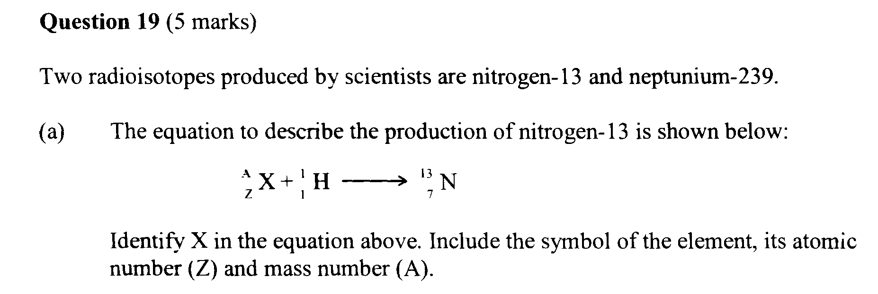

…………………………………………………………………………………………………………
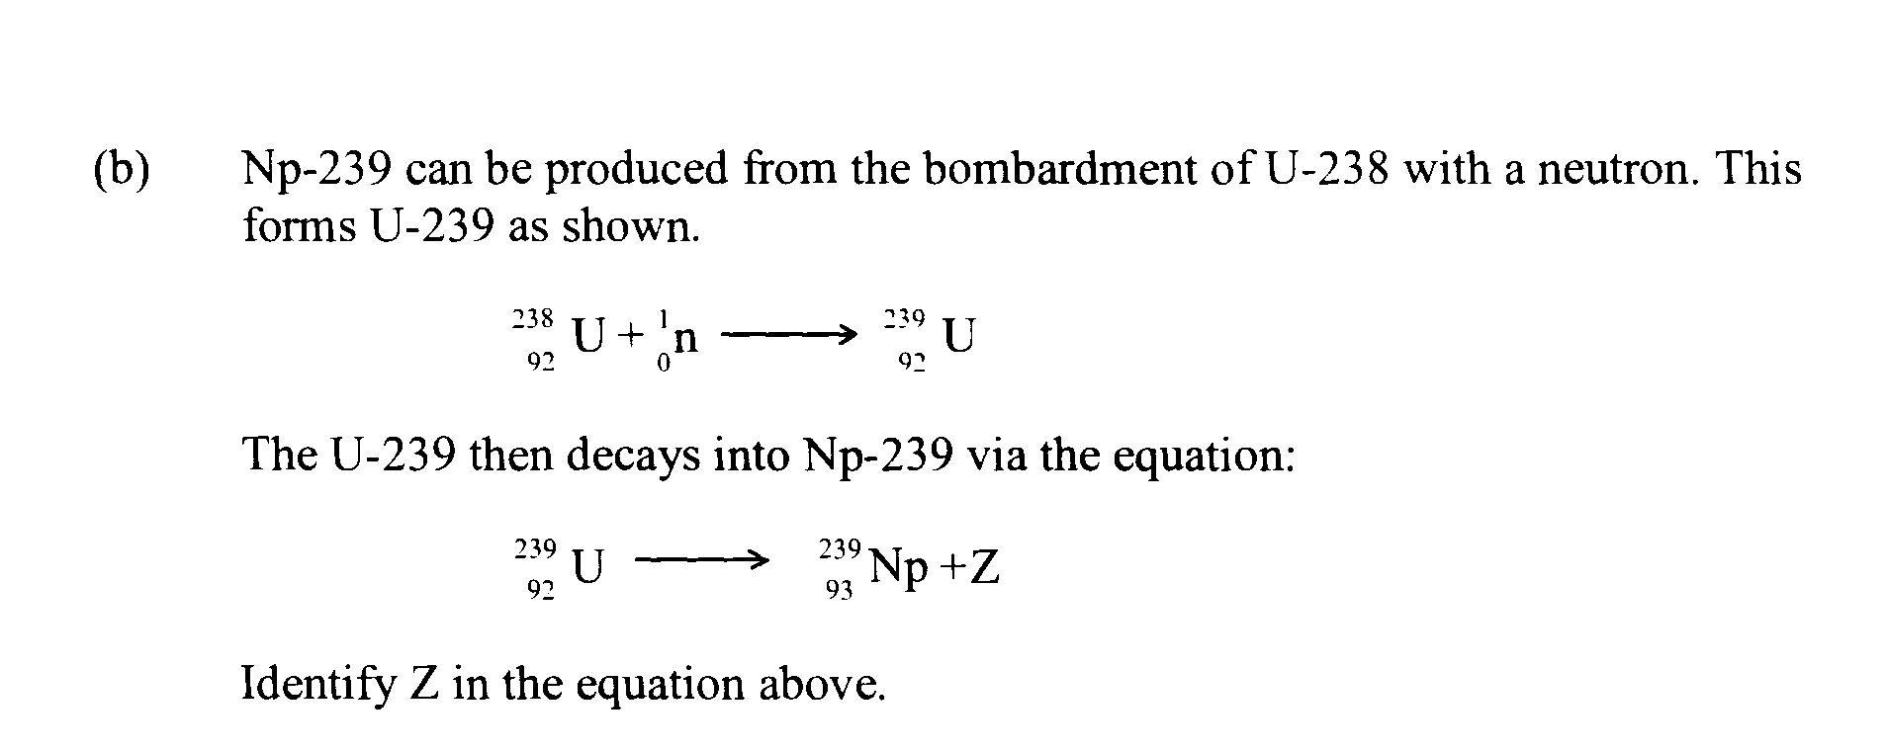

…………………………………………………………………………………………………………

(c) A student researching the production of the above radioisotopes reported that both could be 3
produced in a nuclear reactor.

Assess the accuracy of this statement

…………………………………………………………………………………………………………

…………………………………………………………………………………………………………

…………………………………………………………………………………………………………

…………………………………………………………………………………………………………

…………………………………………………………………………………………………………

…………………………………………………………………………………………………………

…………………………………………………………………………………………………………

…………………………………………………………………………………………………………

…………………………………………………………………………………………………………

Question 20 (4 marks)

A student wanted to compare the heat of combustion of 1-pentanol with that of ethanol. To do this, they burned 1.55 g of 1-pentanol to heat 250.0 mL of water from 10.0ºC to 38.0ºC.

- Using the student’s data, calculate the heat of combustion of 1-pentanol 2

…………………………………………………………………………………………………………

…………………………………………………………………………………………………………

…………………………………………………………………………………………………………

…………………………………………………………………………………………………………

…………………………………………………………………………………………………………

…………………………………………………………………………………………………………

…………………………………………………………………………………………………………

…………………………………………………………………………………………………………

…………………………………………………………………………………………………………

…………………………………………………………………………………………………………

b. Identify how you would expect the student’s value to compare with the literature value 2
(eg in the SI Data Book) for 1-pentanol. Explain your answer

…………………………………………………………………………………………………………

…………………………………………………………………………………………………………

…………………………………………………………………………………………………………

…………………………………………………………………………………………………………

…………………………………………………………………………………………………………

…………………………………………………………………………………………………………

…………………………………………………………………………………………………………

…………………………………………………………………………………………………………

…………………………………………………………………………………………………………

…………………………………………………………………………………………………………

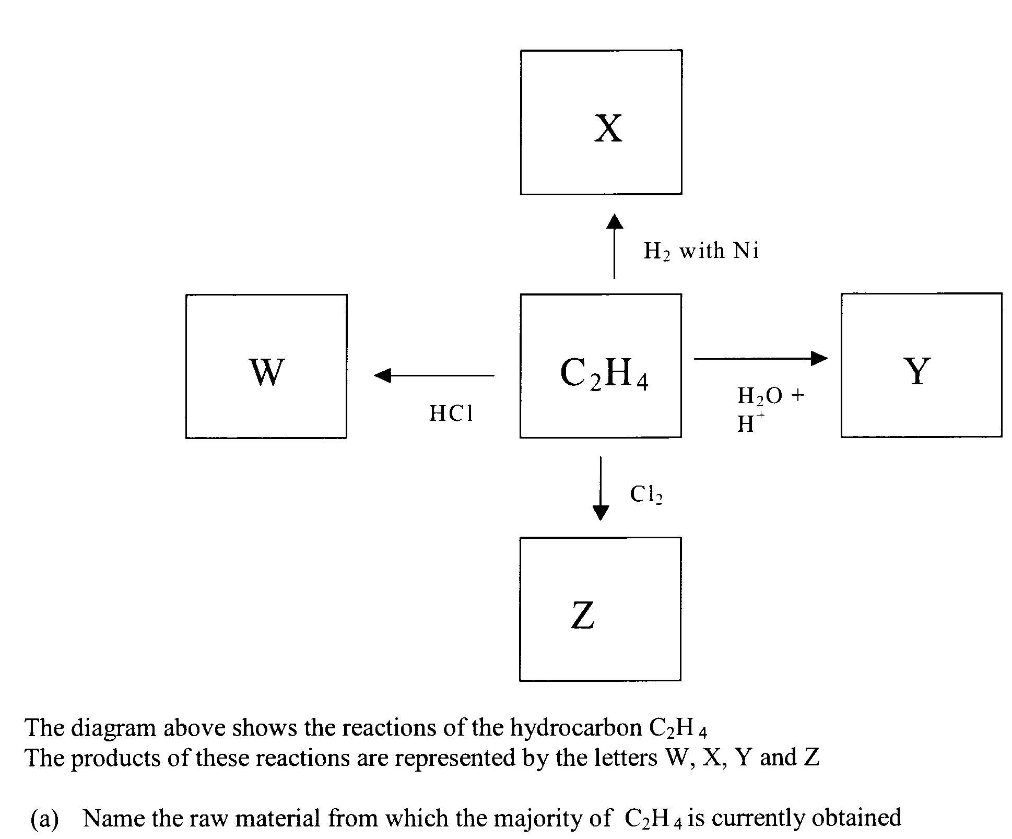
Question 21 (6 marks)

1

…………………………………………………………………………………………………………

(b) Identify and describe the process by which C₂H₄ is traditionally obtained 2

…………………………………………………………………………………………………………

…………………………………………………………………………………………………………

…………………………………………………………………………………………………………

…………………………………………………………………………………………………………

…………………………………………………………………………………………………………

…………………………………………………………………………………………………………

…………………………………………………………………………………………………………

…………………………………………………………………………………………………………

Question 21 (continued)

(c) State the systematic name and write the structural formula for product Z 1

…………………………………………………………………………………………………………

(d) Describe a use of product Y and relate the use to its properties 2

…………………………………………………………………………………………………………

…………………………………………………………………………………………………………

…………………………………………………………………………………………………………

…………………………………………………………………………………………………………

…………………………………………………………………………………………………………

…………………………………………………………………………………………………………

…………………………………………………………………………………………………………

Question 22 (4 marks)

In your HSC course you studies either the dry cell or lead acid cells

(a) Draw a labelled diagram of either the dry cell or lead acid cell 2

(b) Assess the impact of your chosen cell on the environment 2

…………………………………………………………………………………………………………

…………………………………………………………………………………………………………

…………………………………………………………………………………………………………

…………………………………………………………………………………………………………

…………………………………………………………………………………………………………

…………………………………………………………………………………………………………

…………………………………………………………………………………………………………

…………………………………………………………………………………………………………

…………………………………………………………………………………………………………

…………………………………………………………………………………………………………

Question 23 (5 marks)

A student wanted to construct a galvanic cell using a piece of silver metal, a strip of magnesium metal, and suitable other reagents

(a) Write the two half equations for the reactions occurring in the cell 2

…………………………………………………………………………………………………………

…………………………………………………………………………………………………………

(b) Calculate the expected voltage produced by the student’s cell 1

…………………………………………………………………………………………………………

(d) The students result did not agree with the calculated value. Suggest two reasons to 2
account for the variations

…………………………………………………………………………………………………………

…………………………………………………………………………………………………………

…………………………………………………………………………………………………………

…………………………………………………………………………………………………………

…………………………………………………………………………………………………………

…………………………………………………………………………………………………………

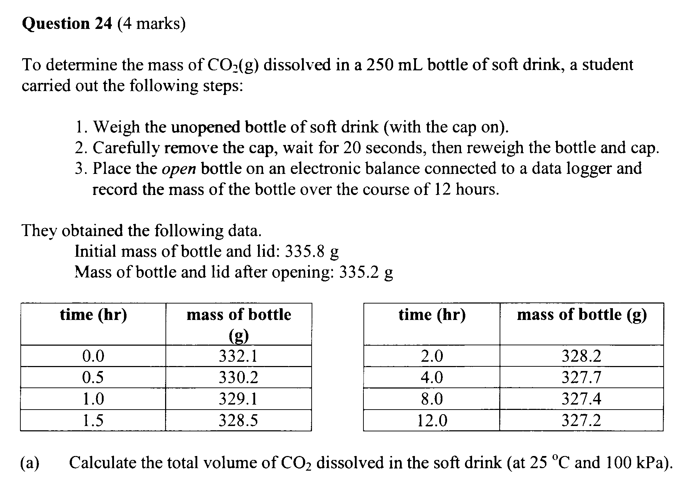

2

…………………………………………………………………………………………………………

…………………………………………………………………………………………………………

…………………………………………………………………………………………………………

…………………………………………………………………………………………………………

…………………………………………………………………………………………………………

…………………………………………………………………………………………………………

(b) Explain how the pH of the soft drink would have changed over the course of the student’s 2
experiment, including an appropriate chemical equation

…………………………………………………………………………………………………………

…………………………………………………………………………………………………………

…………………………………………………………………………………………………………

…………………………………………………………………………………………………………

…………………………………………………………………………………………………………

…………………………………………………………………………………………………………

…………………………………………………………………………………………………………

Question 25 (5 marks)

(a) Compare the ionisation of sulfuric acid and citric acid in water using equations and diagrams 3
to model this process

…………………………………………………………………………………………………………

…………………………………………………………………………………………………………

…………………………………………………………………………………………………………

…………………………………………………………………………………………………………

…………………………………………………………………………………………………………

- 50 mL of hydrochloric acid has a hydrogen ion concentration at 25ºC of 2.1 x 10⁻² mol L⁻¹. What is the pH of this solution?

…………………………………………………………………………………………………………

…………………………………………………………………………………………………………

…………………………………………………………………………………………………………

…………………………………………………………………………………………………………

…………………………………………………………………………………………………………

